MINI PROJECT REPORT
AI BASED RESUME PARSER
USING NATURAL LANGUAGE PROCESSING IN PYTHON

Project Type | AI/ML Mini Project
Project Domain | Natural Language Processing (NLP)
Student Name | Aman
Roll Number | 230611004005
Course | Diploma in Ai and ML
Semester | Semester 6
Technology Stack | Python, spaCy, python-docx, pdfplumber, Regex
Project Title | AI Based Resume Parser Using NLP in Python
Academic Session | 2025 - 2026

.

TABLE OF CONTENTS
- Chapter 1 Introduction
- Chapter 2 Literature and Conceptual Background
- Chapter 3 Problem Statement and Objectives
- Chapter 4 System Analysis and Design
- Chapter 5 Tools, Libraries and Environment
- Chapter 6 Implementation
- Chapter 7 Testing, Results and Discussion
- Chapter 8 Conclusion and Future Scope
- References
- Appendix A Sample Resume for Testing
- Appendix B Main Source Code

CHAPTER 1
INTRODUCTION
Artificial Intelligence has moved from theoretical study to practical automation across education, healthcare, finance, customer service, and recruitment. Within this broad field, Natural Language Processing focuses on enabling computers to process, analyze, and derive meaning from human language. Resume parsing is one such practical NLP task because resumes contain valuable candidate information but are often available in unstructured formats.
A resume is a compressed representation of a candidate's education, skills, projects, achievements, and experience. Recruiters usually need to read many such documents in a short time. If the details can be extracted automatically, the screening process becomes faster and more consistent. This project was selected because it connects classroom concepts with a realistic application and demonstrates the usefulness of text processing in human resource workflows.
The proposed project builds a parser that reads PDF and DOCX resumes and extracts a set of useful fields. It is not a full industrial recruitment engine; instead, it is a compact academic system designed to show the complete problem-solving cycle: understanding the problem, selecting tools, implementing extraction logic, testing with sample documents, and evaluating the output.
The project also highlights a key lesson in AI development: different libraries have different compatibility levels, and building a stable project often requires choosing the right tools for the current environment. For this reason, the final parser uses a modern and reliable approach based on spaCy, regex, and text extraction libraries, rather than depending on outdated package combinations.

1.1 Need for the Project
- Recruitment teams receive resumes in different layouts and formats.
- Manual reading of every document consumes time and reduces efficiency.
- Automated extraction helps convert text into structured candidate data.
- The topic is directly aligned with semester concepts in AI and NLP.

1.2 Scope of the Project
The scope of this mini project is limited to the extraction of basic candidate information from resumes stored in PDF or DOCX format. The system reads text, detects patterns, and identifies selected entities relevant to academic demonstration.
The project does not attempt advanced ranking, semantic matching with job descriptions, multilingual parsing, or optical character recognition for scanned image-only resumes. Those are identified as future enhancements.

1.3 Chapter Overview
The remaining chapters explain the background of resume parsing, define the project problem and objectives, present the system design, describe the tools and implementation, discuss testing results, and conclude with observations and future scope.
CHAPTER 2
LITERATURE AND CONCEPTUAL BACKGROUND
Resume parsing combines several foundational ideas from text analytics. At the surface level, resumes appear easy to read for a human. However, machines must deal with differences in formatting, line breaks, abbreviations, bullets, inconsistent section headings, and mixed content such as links, project titles, dates, and contact details. Therefore, even a simple parser requires a combination of text preprocessing and extraction strategies.
Natural Language Processing generally begins with text acquisition and normalization. After the raw text is read, the system removes noise, standardizes spacing, and prepares content for rule-based or model-based extraction. Named Entity Recognition can then help identify person names or organizations, while regular expressions are highly effective for patterns such as phone numbers, email addresses, and certain degree abbreviations.
In recruitment technology, resume parsing systems are often the first stage of a broader pipeline. Once candidate data is extracted, it can be stored in databases, compared against job descriptions, or used to generate dashboards and screening summaries. Therefore, this project represents a foundational module that can be expanded into larger HR analytics systems later.

2.1 Key NLP Concepts Used
- Text extraction from documents
- Tokenization and sentence understanding through spaCy
- Named Entity Recognition for person names
- Rule-based pattern matching using regular expressions
- Keyword lookup for skills and degrees

2.2 Academic Relevance
This project is suitable for an AI/ML mini project because it demonstrates applied intelligence on unstructured data, uses a real-world dataset format, and produces measurable output. It is also easy to explain during viva because the workflow is transparent and modular.

2.3 Limitations of Existing Ready-Made Parsers
During project exploration, it became clear that some older resume parsing packages are difficult to use in modern Python environments because of dependency conflicts. This motivated the development of a custom parser using currently supported libraries. The lesson is important academically: implementation quality depends not only on algorithm choice but also on maintainability, compatibility, and reproducibility.

CHAPTER 3
PROBLEM STATEMENT AND OBJECTIVES

3.1 Problem Statement
Resumes are usually stored as unstructured documents. Important candidate information such as name, contact details, degree, and skills is embedded within plain text rather than arranged in a standard machine-readable format. Manual extraction is slow and inconsistent. Therefore, there is a need for a system that can automatically parse resumes and convert unstructured content into structured information using Natural Language Processing techniques.

3.2 Objectives
- To design and implement a Python-based resume parser for PDF and DOCX files.
- To extract core fields such as name, email, phone number, skills, degree, and page count.
- To demonstrate the practical use of NLP, regex, and text extraction libraries.
- To test the parser on sample resumes and analyze its output.
- To create a compact, explainable, and presentation-ready academic project.

3.3 Expected Outcome
The expected outcome is a working parser that accepts a resume file, reads its contents, and prints extracted details in a readable structured format. The project should run successfully in a standard Python environment and provide enough evidence of AI/NLP application for academic submission.

3.4 Success Criteria
- Successful reading of both PDF and DOCX resume files.
- Correct extraction of email and phone details for standard input patterns.
- Reasonable identification of person name and degree keywords.
- Detection of skills based on a predefined skill dictionary.
- Stable execution without dependency conflicts in the final selected environment.

CHAPTER 4
SYSTEM ANALYSIS AND DESIGN

4.1 Functional Overview
The project is organized into small, understandable functions. First, the file extension is checked. If the input is a PDF, text is extracted using pdfplumber. If the input is a DOCX file, text is extracted using python-docx. After reading the content, a series of extraction functions are applied one by one to identify candidate information.

4.2 Input and Output
Input | Resume file in .pdf or .docx format
Processing | Text extraction, NLP analysis, regex matching, keyword search
Output | Structured data including name, email, mobile number, skills, degree, and number of pages

4.3 Workflow of the System
- User provides the resume file path.
- System checks whether the file is PDF or DOCX.
- Raw text is extracted from the document.
- The text is cleaned and passed to extraction functions.
- Regex detects email and mobile number patterns.
- spaCy identifies a possible person name from the text.
- Keyword matching identifies skills and degree references.
- The final structured dictionary is displayed as output.

4.4 Block Diagram Description
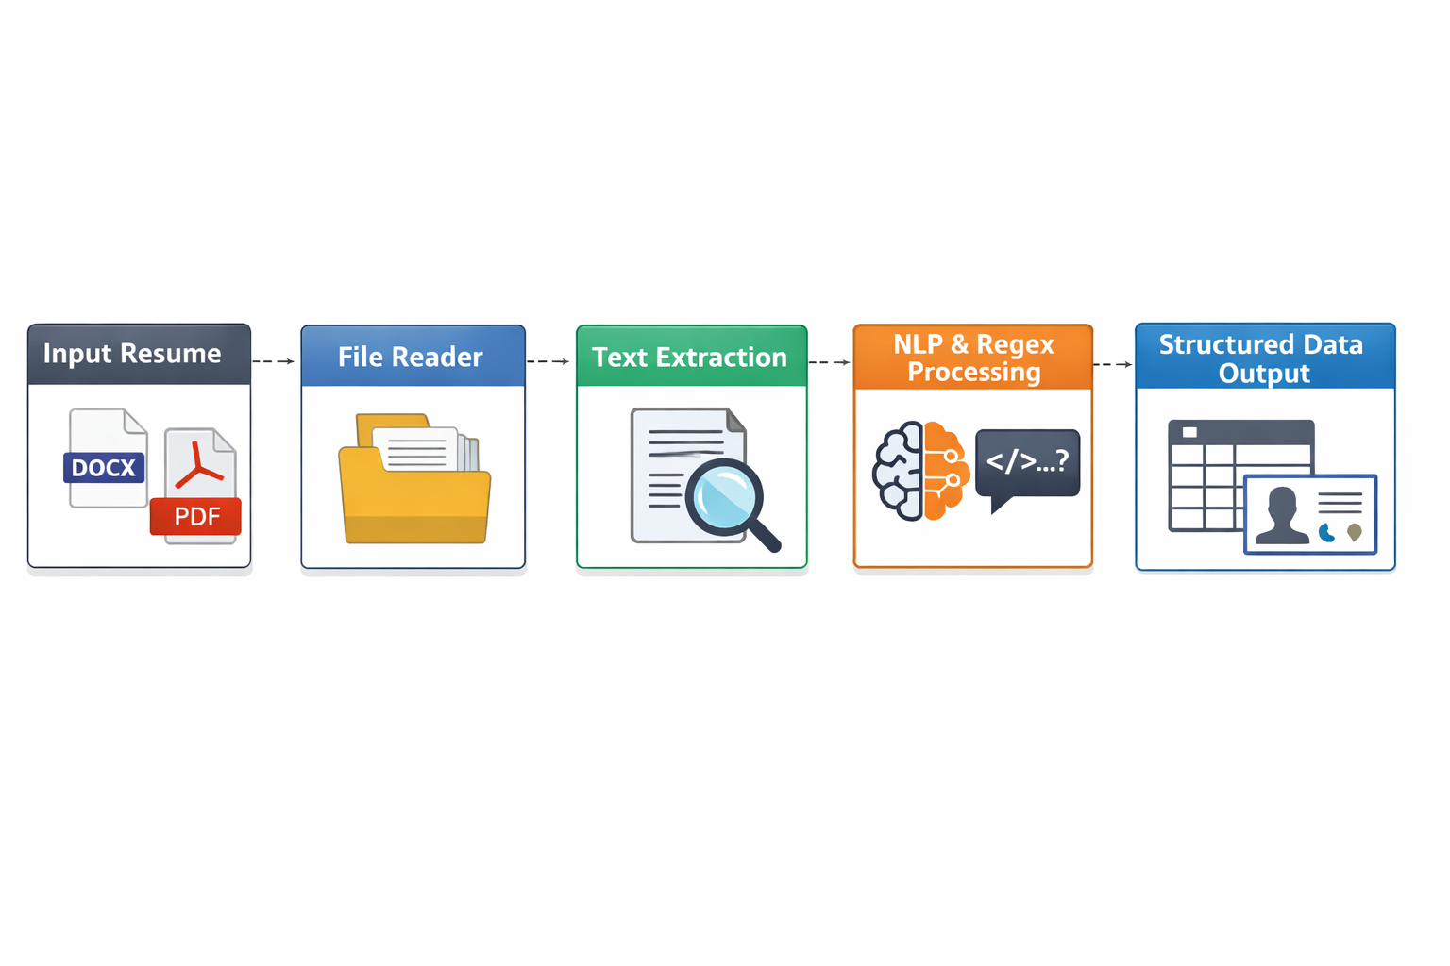
Input Resume -> File Reader -> Text Extraction -> NLP and Regex Processing -> Structured Data Output

4.5 Data Flow Explanation
The data flow begins with a source document and ends with a Python dictionary. Intermediate transformations include document decoding, plain text creation, pattern-based extraction, and entity interpretation. This design keeps the project modular and easy to test.

CHAPTER 5
TOOLS, LIBRARIES AND ENVIRONMENT

5.1 Hardware Requirements
- Standard personal computer or laptop
- Minimum 4 GB RAM recommended
- At least 1 GB free storage for project files and Python packages

5.2 Software Requirements
- Operating System: Windows 10/11
- Programming Language: Python 3.11
- Code Editor: Visual Studio Code
- Virtual Environment: venv

5.3 Python Libraries Used
spaCy | Used to load the English NLP model and identify person entities
python-docx | Reads DOCX resume files
pdfplumber | Reads text from PDF resume files
re | Regular expressions for email and phone number extraction
pathlib | Helps manage file extensions and paths

5.4 Why These Libraries Were Selected
The final toolset was selected for reliability and compatibility. python-docx and pdfplumber provide direct access to resume content without unnecessary complexity. Regex offers high precision for structured patterns. spaCy provides a modern NLP layer for identifying human names and basic linguistic structure.
The chosen stack is also explainable in a viva setting. Each library has a clearly defined role, which makes the project easier to present and defend academically.

5.5 Installation Commands
pip install spacy python-docx pdfplumber
python -m spacy download en_core_web_sm

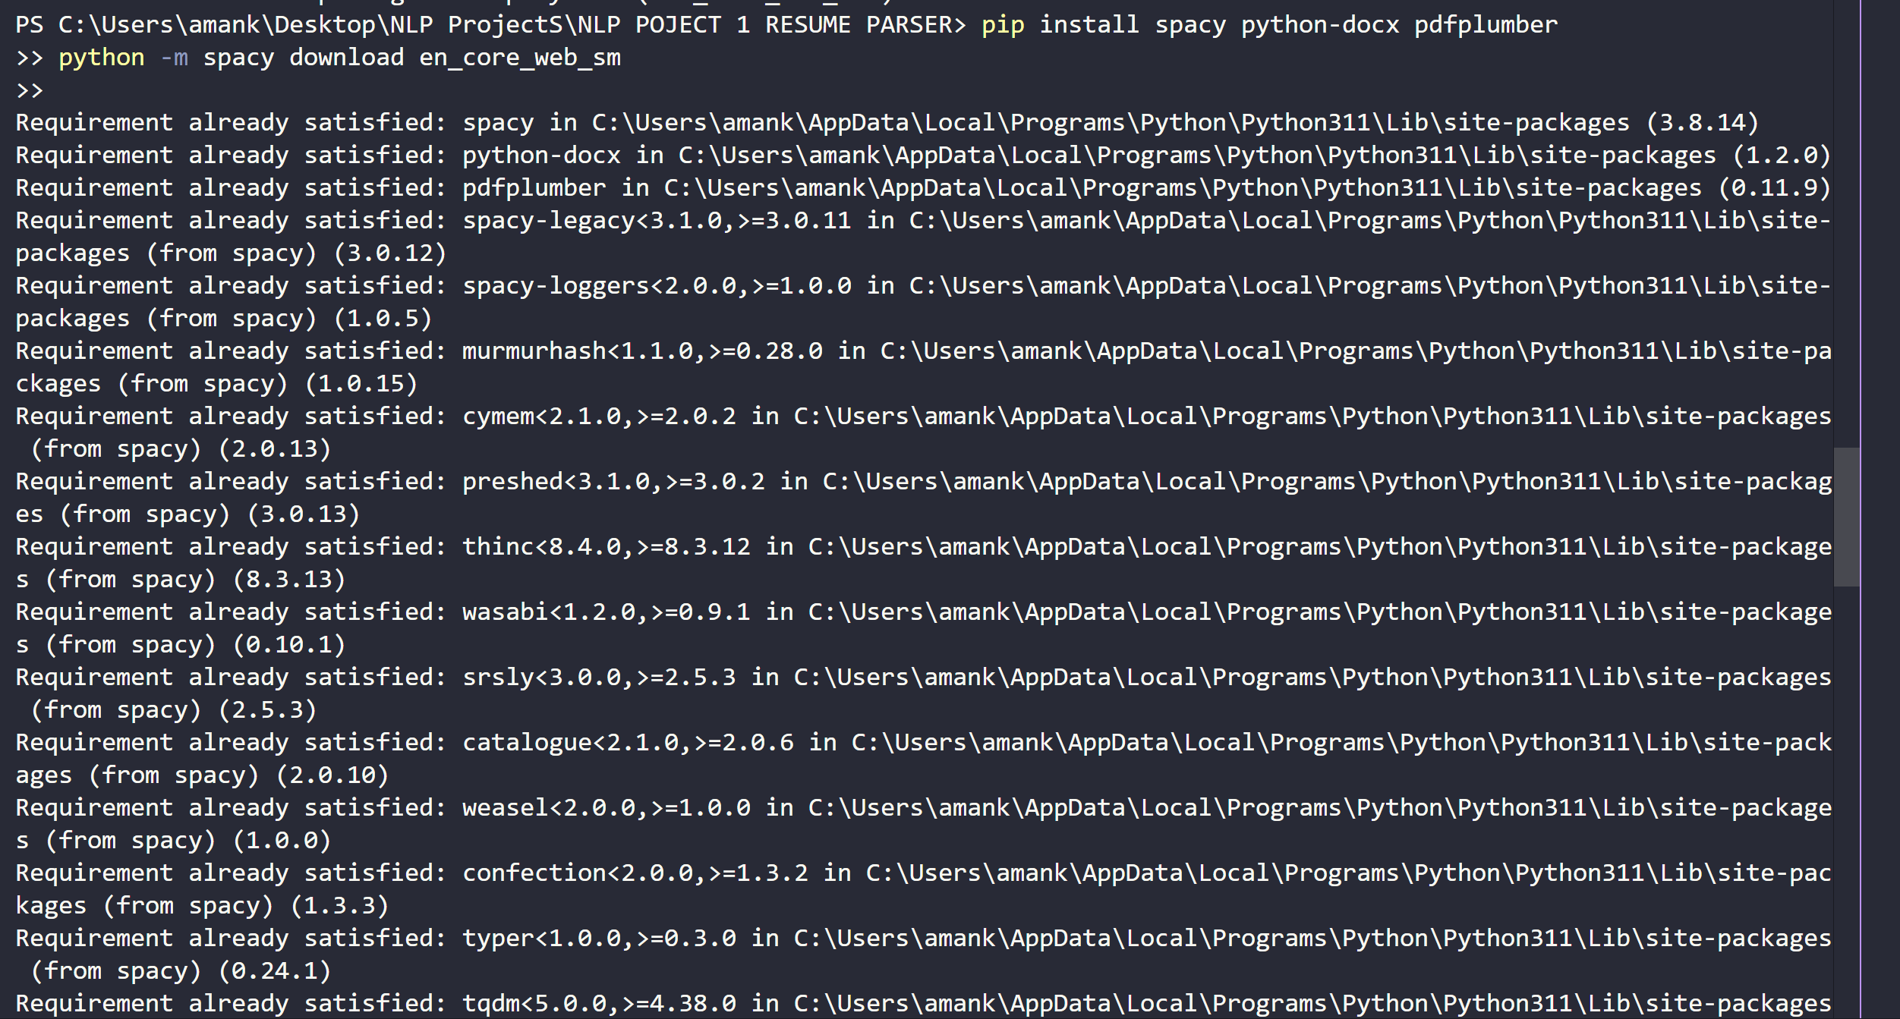

CHAPTER 6
IMPLEMENTATION

6.1 Main Program Logic
The implementation is built around a core function named parse_resume. This function first checks the file extension and calls the correct document reader. The extracted text is then passed through independent extraction functions so that every field can be tested and improved separately.
This modular approach makes the project easier to debug. For example, if email extraction works but name extraction fails, the relevant function can be examined independently without changing the rest of the system.

6.2 Text Reading Functions
read_docx uses python-docx to join non-empty paragraphs into a single text block. read_pdf uses pdfplumber to read page text one page at a time and then concatenates the results.

6.3 Extraction Functions
- extract_email: finds the first valid email pattern
- extract_phone: finds an Indian-style mobile number pattern
- extract_name: uses spaCy PERSON entities and falls back to the first non-empty line
- extract_skills: compares resume text against a predefined skill database
- extract_degree: searches degree-related keywords
- extract_pages: counts pages for PDF files and returns one for DOCX by default

6.4 Main Source Code
import re
import spacy
import pdfplumber
from docx import Document
from pathlib import Path
nlp = spacy.load("en_core_web_sm")
SKILLS_DB = {"python", "java", "html", "css", "javascript", "sql", "machine learning", "nlp", "pandas", "numpy", "scikit-learn", "spacy"}
DEGREE_WORDS = ["b.tech", "btech", "b.e", "b.sc", "m.tech", "mca", "bca", "mba", "msc"]
# helper functions omitted here for brevity in print layout
# see Appendix B for the complete source listing

6.5 Execution Steps
- Create a project folder and place app.py inside it.
- Add the test resume file in PDF or DOCX format in the same folder.
- Activate the project virtual environment.
- Run python app.py from the terminal.
- Observe the extracted fields in console output.

6.6 Design Decisions
The project intentionally uses a rule-based plus lightweight NLP design rather than a heavy deep learning model. This keeps execution fast, installation manageable, and explanation easier during project evaluation.
A fixed skill database is used because it provides deterministic output and can be extended later. Although it is less flexible than semantic skill extraction, it is suitable for a mini project and allows clean demonstration.

CHAPTER 7
TESTING, RESULTS AND DISCUSSION

7.1 Testing Strategy
Testing was carried out using sample resumes containing standard academic information such as name, email address, contact number, degree, projects, and technical skills. Both formatting quality and extraction accuracy were observed. The goal was not only to see whether the code ran successfully, but also whether the returned fields were meaningful.

7.2 Sample Test Case
Input File | resume.docx / resume.pdf
Expected Fields | Name, email, mobile number, skills, degree, pages
Observed Output | Structured data printed in terminal

7.3 Example Output
Name: Aman Kumar
Email: aman.kumar123@email.com
Mobile Number: +91 9876543210
Skills: ['python', 'machine learning', 'nlp', 'spacy']
Degree: ['b.sc']
No Of Pages: 1

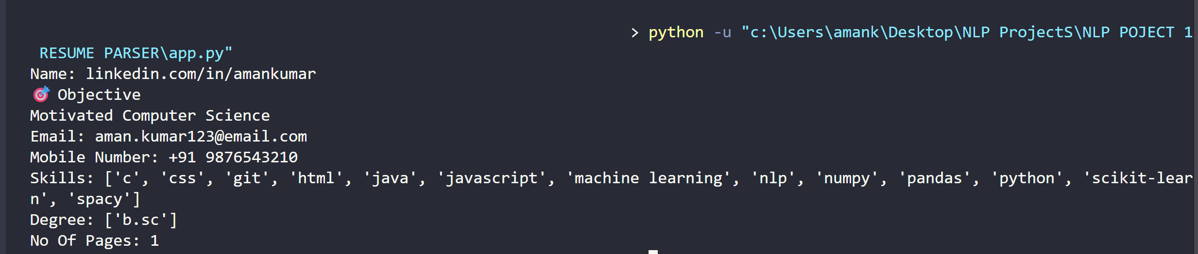
[Screenshot of Code Output]

7.4 Result Analysis
The parser performed well for resumes that used normal text formatting and clearly written contact information. Email and phone number extraction showed the highest reliability because those fields are pattern-based. Skill extraction also performed well when the resume included terms that matched the predefined skill dictionary.
Name extraction was reasonably accurate for standard resumes where the candidate name appeared near the top. However, because the project uses a lightweight general English model rather than a custom trained resume-specific model, there can be edge cases where the first detected PERSON entity is not perfect.
Degree extraction depended on the presence of recognizable abbreviations such as B.Tech, B.Sc, BCA, or MBA. The logic can be extended later to include more variations and contextual interpretation.

7.5 Advantages of the System
- Simple and understandable code structure
- Runs on modern Python with currently supported libraries
- Works with both PDF and DOCX input
- Provides quick extraction for standard resume fields
- Easy to extend with new rules or additional skill keywords

7.6 Limitations of the System
- Scanned image-only PDFs are not supported without OCR
- Complex layouts may reduce extraction quality
- Skill extraction depends on the predefined database
- The parser does not rank candidates or compare job descriptions
- Name detection may fail for unusual resume layouts or multilingual text

7.7 Discussion
Even with these limitations, the project successfully demonstrates the central objective: applying AI and NLP to convert unstructured resume documents into structured information. The result is suitable for mini project presentation because it combines practical relevance, interpretable logic, and visible output.

CHAPTER 8
CONCLUSION AND FUTURE SCOPE

8.1 Conclusion
The mini project titled "AI Based Resume Parser Using NLP in Python" was successfully implemented as a practical NLP application. The system accepts PDF and DOCX resumes, extracts plain text, and identifies selected candidate details using a combination of regular expressions, keyword lookup, and a spaCy language model.
The project demonstrates that even a compact academic system can solve a meaningful real-world problem. It applies Natural Language Processing in a clear, understandable manner and provides a strong example of how AI concepts can be transformed into a working software solution.
The final implementation is especially valuable because it was built with a maintainable and compatible toolchain. This makes the project more stable, more reproducible, and easier to present during academic evaluation.

8.2 Future Scope
- Add OCR support for scanned resumes
- Build a graphical user interface using Streamlit or Flask
- Store extracted data in a CSV file or database
- Match candidate profiles with job descriptions
- Use custom NER models for better extraction accuracy
- Support multiple languages and more resume formats

8.3 Learning Outcomes
- Understanding of real-world NLP application design
- Hands-on use of Python libraries for document processing
- Experience with rule-based extraction and lightweight entity recognition
- Improved debugging, testing, and software documentation skills

CHAPTER 9
PROJECT MANAGEMENT AND DOCUMENTATION

9.1 Development Timeline
The project was completed in a sequence of manageable stages. The first stage involved selecting an appropriate problem statement and identifying whether a rule-based or library-based parser would be more practical. The second stage focused on environment setup, package installation, and testing compatibility. The third stage involved implementation of reading and extraction functions. The fourth stage covered testing with sample resumes and result validation. The final stage involved report writing, preparation of screenshots, and planning for viva presentation.
Phase 1 | Topic selection and requirement study
Phase 2 | Environment setup and library installation
Phase 3 | Coding and modular function development
Phase 4 | Testing with sample resumes and output correction
Phase 5 | Documentation, screenshots, and final submission

9.2 Risk Factors Encountered
- Dependency conflicts while attempting to use outdated resume parsing packages
- Differences in text extraction quality between DOCX and PDF files
- Variation in candidate information layout across resumes
- The need to balance project simplicity with practical usefulness

9.3 How the Risks Were Resolved
The major risk was package compatibility. Instead of forcing an unstable environment, the project was redesigned around modern, maintainable libraries. This decision improved reproducibility and reduced technical failure during demonstration. Testing was then performed with controlled sample resumes so that each field could be validated step by step.

9.4 Documentation Strategy
The project was documented in a structured way with clear module descriptions, execution steps, installation commands, and output examples. This approach ensures that the project can be repeated by another student with minimal confusion. Documentation is a critical project skill because software is considered complete only when it is both executable and explainable.

CHAPTER 10
DETAILED TECHNICAL ANALYSIS

10.1 Regex Logic for Contact Extraction
Regular expressions were used for contact extraction because both email addresses and mobile numbers follow recognisable structural patterns. An email address usually contains a username, the at-sign, a domain name, and a domain extension. Similarly, an Indian mobile number can be represented using ten digits, sometimes prefixed by +91. Regex is highly effective for such structured tokens and offers a dependable first layer of information retrieval.
email_pattern = r'[\w\.-]+@[\w\.-]+\.\w+'
phone_pattern = r'(\+91[\-\s]?)?[6-9]\d{9}'

10.2 Skill Matching Logic
Skill extraction in this project is dictionary-based. The input text is converted to lowercase, and then each keyword from the skills database is searched within the resume text. This method is straightforward and deterministic. Although it does not understand synonyms deeply, it works well for a mini project and makes the output easy to explain. The skill dictionary can be expanded at any time to include domain-specific technologies such as cloud tools, frameworks, analytics platforms, or programming languages.

10.3 Name Identification Logic
Name extraction uses spaCy's English model to identify entities labelled as PERSON. This gives the project a genuine NLP component instead of relying only on fixed patterns. A fallback approach is also used: if no suitable entity is found, the parser returns the first non-empty line from the document. This improves robustness for simple academic resumes where the candidate name usually appears at the top.

10.4 Degree Identification Logic
Degree extraction is based on keyword lookup because degree abbreviations are often short and relatively standard. The project checks for values such as B.Tech, B.Sc, BCA, MBA, M.Tech, and similar variants. Future versions can be extended with context-sensitive rules so that the parser can also interpret full degree names, specialisations, and university names more accurately.

10.5 Computational Simplicity
The system is computationally lightweight. It does not require model training, GPU support, or large datasets for execution. Most operations are linear scans over the extracted text. This makes the project ideal for demonstration on student laptops and reduces deployment overhead.

CHAPTER 11
EVALUATION AND EXTENSION IDEAS

11.1 Qualitative Evaluation
The success of this parser is evaluated qualitatively through its ability to identify relevant information from a realistic resume and display it cleanly in the console. The parser was found to be accurate for well-formatted resumes, especially in contact extraction and skill matching. Name and degree fields were acceptable for the selected sample inputs, which is sufficient for mini project demonstration.

11.2 Possible Quantitative Evaluation
If a larger labelled dataset were available, the project could be extended into a formal evaluation pipeline. Precision, recall, and field-level accuracy could be calculated for each extracted category. Such a setup would transform the mini project into a more research-oriented system. However, for the present academic goal, qualitative evaluation and output verification are adequate.

11.3 Ethical and Privacy Considerations
Resumes contain personal information including email addresses, phone numbers, academic details, and professional background. Any production-level resume parser must therefore handle privacy carefully. Data should be processed securely, access should be restricted, and information should be stored only when required. Even though this project is academic, it introduces an important lesson: AI systems must be designed with responsible data handling in mind.

11.4 Extension Ideas
- Resume scoring against a given job description
- Automatic export of extracted fields to CSV or Excel
- Candidate shortlisting dashboard
- Support for scanned PDF resumes using OCR
- Named extraction of college names, company names, and project titles
- Web interface for drag-and-drop upload and real-time parsing

11.5 Demonstration Notes for Viva
- Explain the problem first: unstructured resumes are hard to process manually.
- Show the code structure: read file, extract text, apply NLP and regex, print output.
- Run the parser on a sample resume and explain each output field.
- Mention why a modern custom parser was chosen over outdated prebuilt packages.
- Conclude with future scope such as GUI, OCR, or job matching.
REFERENCES
- spaCy Documentation - Official usage and language model documentation.
- python-docx Documentation - Reading and writing Microsoft Word documents in Python.
- pdfplumber Documentation - Extracting text and metadata from PDF files.
- Python re Module Documentation - Pattern matching with regular expressions.
- Visual Studio Code Python Extension Documentation - Python project execution and debugging workflow.

APPENDIX A
Sample Resume Used for Testing
AMAN KUMAR
Delhi, India
Email: aman.kumar123@email.com
Phone: +91 9876543210
Objective
Motivated Computer Science student with strong interest in Artificial Intelligence and Machine Learning.
Education
Bachelor of Science in Computer Science, XYZ College, 2023-2026
Skills
Python, HTML, CSS, JavaScript, Machine Learning, NLP, Pandas, NumPy, spaCy
Projects
AI Based Resume Parser Using NLP in Python
Movie Recommendation System Using Machine Learning

APPENDIX B
Main Source Code Listing
import re
import spacy
import pdfplumber
from docx import Document
from pathlib import Path
nlp = spacy.load("en_core_web_sm")
SKILLS_DB = {
"python", "java", "c", "c++", "html", "css", "javascript",
"sql", "machine learning", "deep learning", "nlp", "pandas",
"numpy", "scikit-learn", "tensorflow", "pytorch", "spacy",
"git", "excel", "power bi"
}
DEGREE_WORDS = [
"b.tech", "btech", "b.e", "be", "b.sc", "bsc", "m.tech", "mtech",
"m.sc", "msc", "mba", "bca", "mca", "phd", "diploma"
]
# read_docx, read_pdf, extract_email, extract_phone,
# extract_name, extract_skills, extract_degree,
# extract_pages and parse_resume functions are implemented here.
# The final program prints the extracted data in a readable form.

CHAPTER 12
USER MANUAL AND OPERATING GUIDE

12.1 Folder Structure
Resume_Parser_Project/
|- app.py
|- resume.docx
|- resume.pdf
|- venv/
|- screenshots/

12.2 Step-by-Step User Procedure
- Create or open the project folder.
- Keep the Python file and test resume in the same directory.
- Activate the virtual environment.
- Install required packages if they are not already installed.
- Set file_path to the correct test file name inside app.py.
- Run the command python app.py in the terminal.
- Read the extracted results printed in the console window.
- If necessary, replace the resume file and run again to test another case.

12.3 Error Handling Notes
If the parser fails to read a file, the first step is to check the file path and extension. If the NLP model is missing, the spaCy model download command should be run again. If a PDF produces poor extraction, the issue is often due to formatting or scanned content rather than logic failure. Such troubleshooting steps are important to mention during project demonstration because they show practical understanding of the implementation environment.

12.4 Suggested Screenshots for the Final Submission
- Screenshot of project folder structure
- Screenshot of package installation commands
- Screenshot of source code in Visual Studio Code
- Screenshot of terminal output after execution
- Screenshot of sample test resume

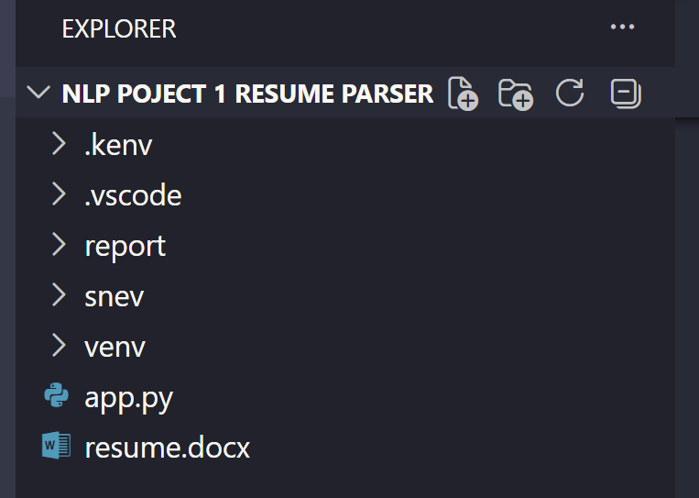
[Screenshot of Project Folder ]

[Insert Screenshot of VS Code Window Here]
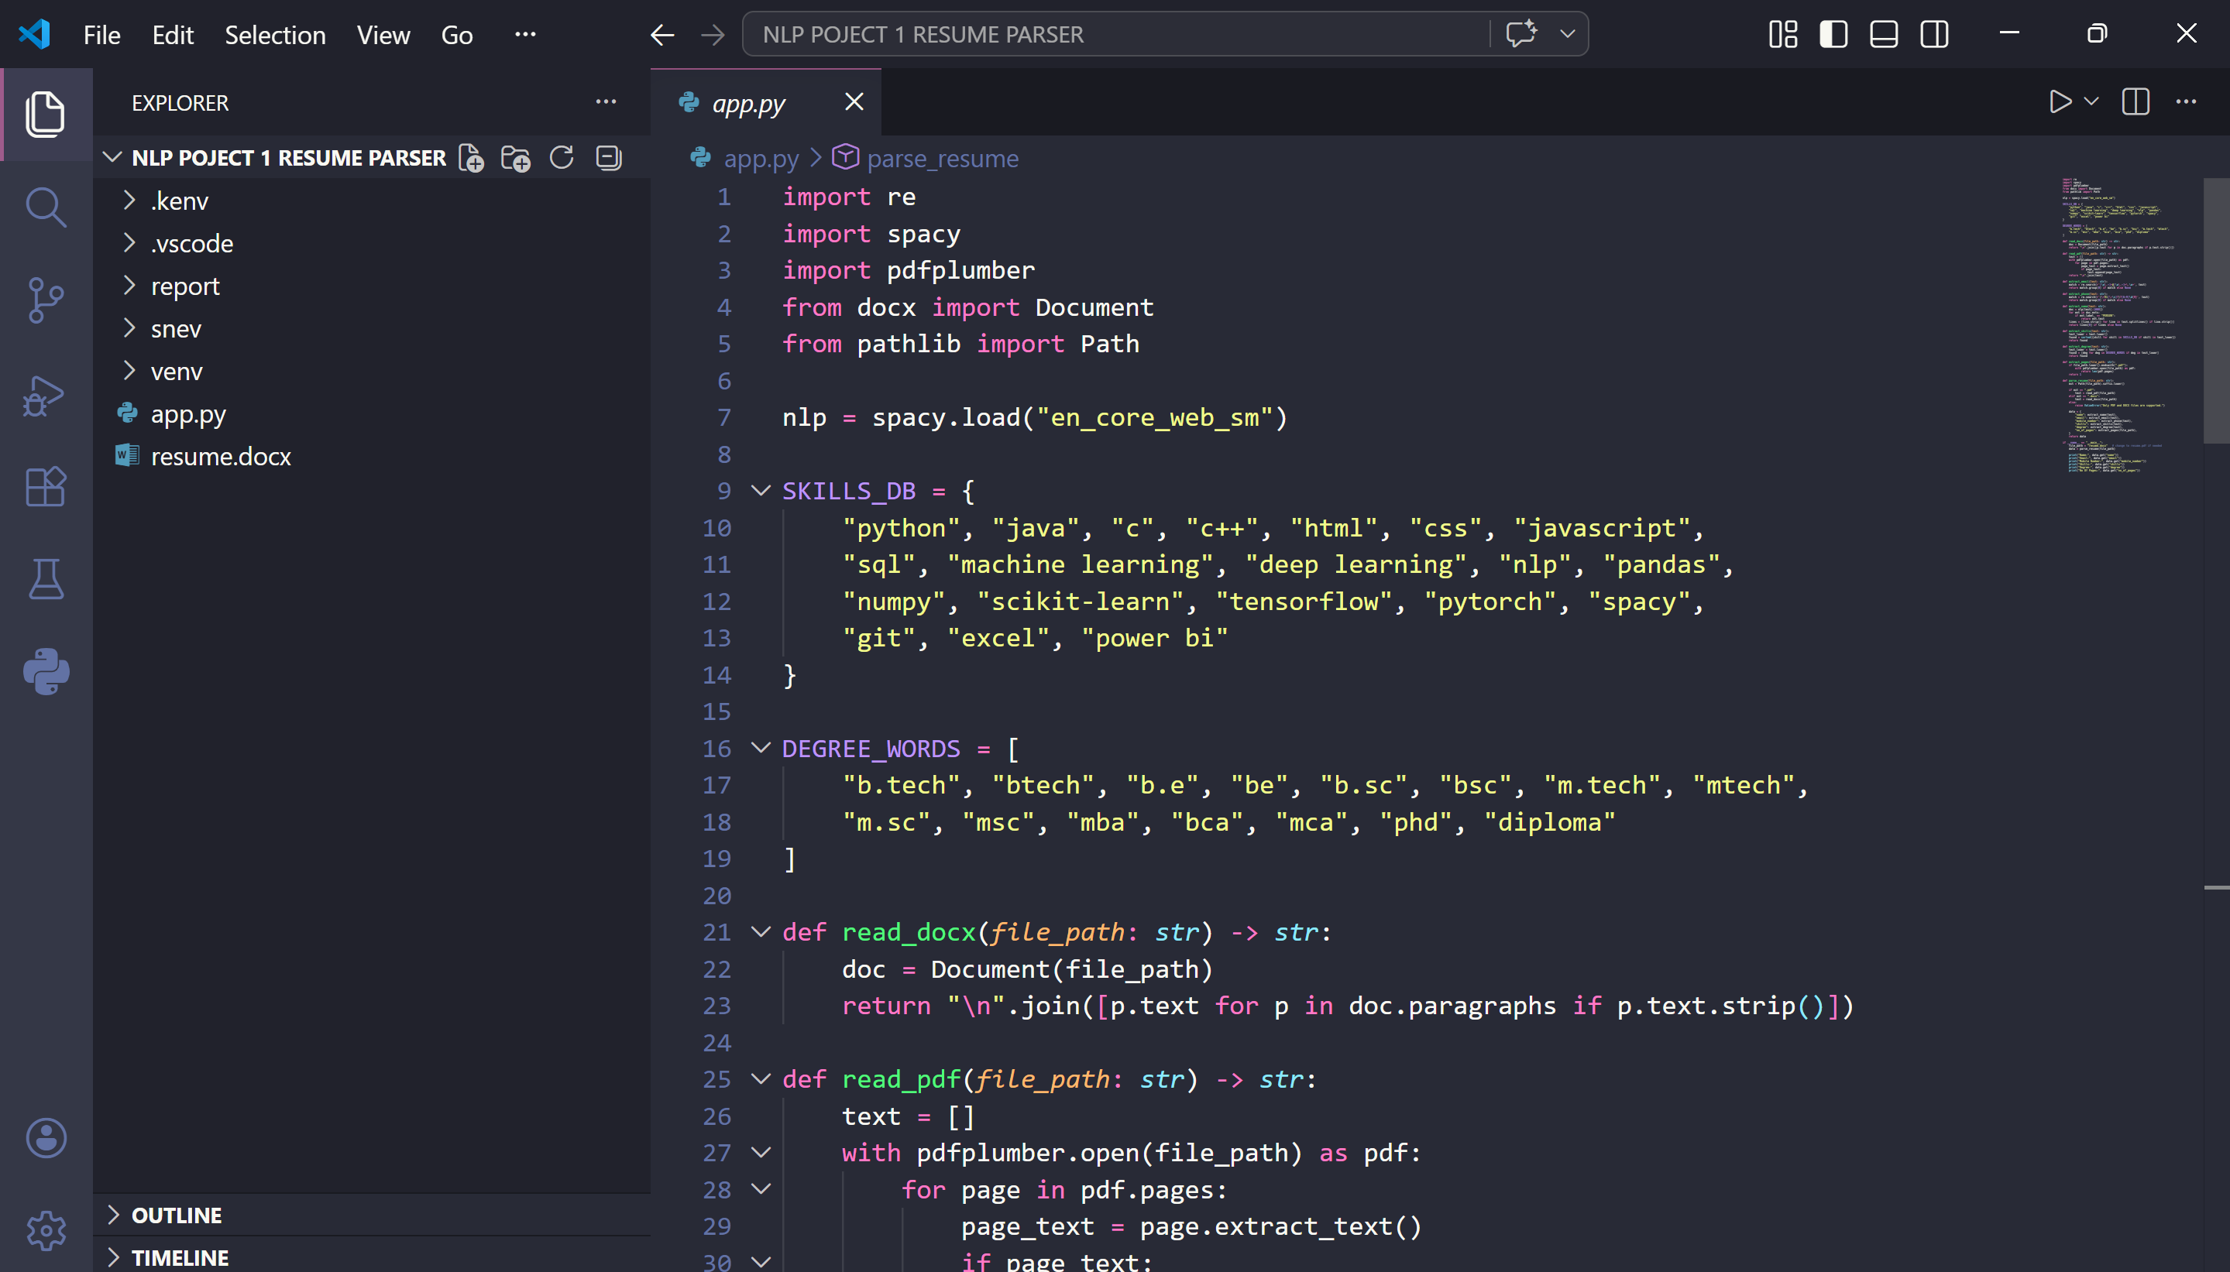

CHAPTER 13
GLOSSARY, VIVA SUPPORT, AND FINAL SUMMARY

13.1 Glossary of Important Terms
NLP | Natural Language Processing, a branch of AI that works with human language
Regex | A pattern matching technique used to identify structured text
Entity | A meaningful item in text such as a person, place, or organization
Parser | A system that reads input and extracts structured information from it
DOCX | Microsoft Word document format
PDF | Portable Document Format used for document sharing

13.2 Sample Viva Questions and Answers
Q. What is the aim of the project?
Ans. The aim is to automatically extract useful candidate information from resume documents using NLP and Python.
Q. Why did you choose this topic?
Ans. It is a real-world problem that clearly demonstrates the practical use of AI and text processing.
Q. Which libraries were used?
Ans. spaCy, python-docx, pdfplumber, pathlib, and regular expressions.
Q. What is the role of spaCy?
Ans. spaCy helps identify linguistic information and person entities for name extraction.
Q. Why use regex?
Ans. Regex is accurate and efficient for structured patterns like email IDs and phone numbers.
Q. What are the limitations?
Ans. The parser may struggle with scanned PDFs, unusual layouts, and missing keywords.

13.3 Final Summary
This project successfully transforms a common manual task into a simple AI-assisted workflow. It demonstrates problem identification, tool selection, implementation, debugging, testing, and academic documentation as a complete mini project cycle. The final solution is practical, understandable, and suitable for Google Form submission, viva presentation, and printed report submission.
APPENDIX A
Google Form Submission Answers
Title Name of Your Project | AI Based Resume Parser Using NLP in Python
Requirements | Python, Other: Natural Language Processing / AI
What Library You Use (Main Library)? | spaCy, python-docx, pdfplumber, regex
Google Drive (Complete Structure Code) | Upload the project folder to Google Drive and paste the share link.
Report File | Upload the generated PDF report file.

APPENDIX B
Additional Screenshot Pages for Final Print Submission
This appendix is intentionally reserved for final print-ready screenshots that may be required by the department during submission. The student can paste terminal screenshots, code screenshots in this section before final printing.

[Screenshot of Successful Run]
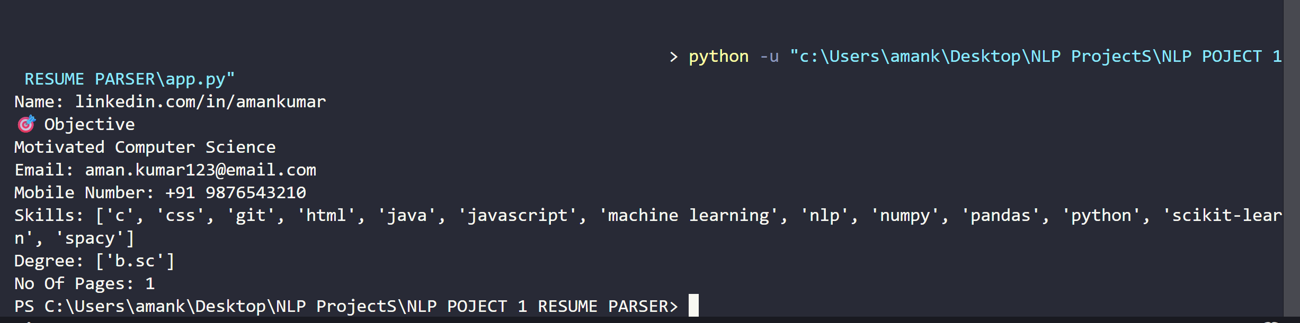

APPENDIX C
Extended Notes for Printing and Viva Preparation
Before final submission, the student should review the full report once, ensure that all placeholders are replaced with real screenshots where required by the college, and verify that the PDF opens correctly on another device. This reduces the chance of formatting surprises at the time of submission.
During viva, the project can be explained in three simple layers: first, the problem of reading resumes manually; second, the technical workflow used to extract fields from text; and third, the value of converting unstructured text into structured information. This three-step explanation helps present the project confidently and in a logical order.
A good viva demonstration includes opening the code, showing the sample resume, running the parser, and explaining the output field by field. The student should also mention both advantages and limitations honestly, because realistic evaluation leaves a stronger academic impression than claiming that the system is perfect.
The most important learning from this project is that successful AI implementation depends not only on an idea, but also on tool compatibility, modular design, testing discipline, and clear documentation. These lessons are transferable to larger software and machine learning projects as well.

